

Assignment 10

CS 432 Spring 2017



May 1, 2017

Michelle Graham

**Q1:**

Most of the code for this question was provided in the slides and the PCI book. The cosine function was easily found on Stack Overflow.

Code Snippet**:**

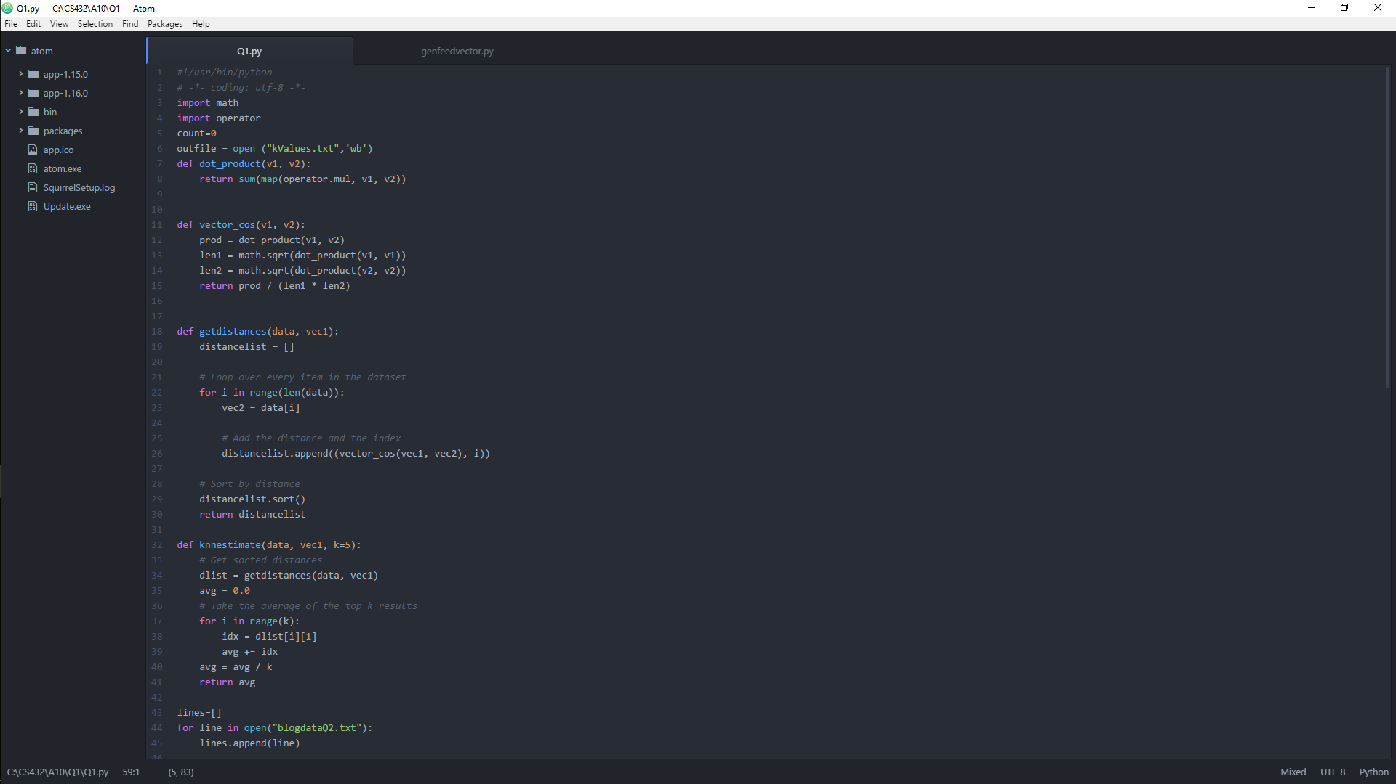

**Q2:**

**Q3:**

Because I was unable to complete this assignment earlier in the semester, I got help from a classmate so that I could evaluate their code. I used their data to generate mementoes of each 1000 unique links. I compared the data to their original graphed data from assignment 2. This was done by use of the histogram function in r studio.

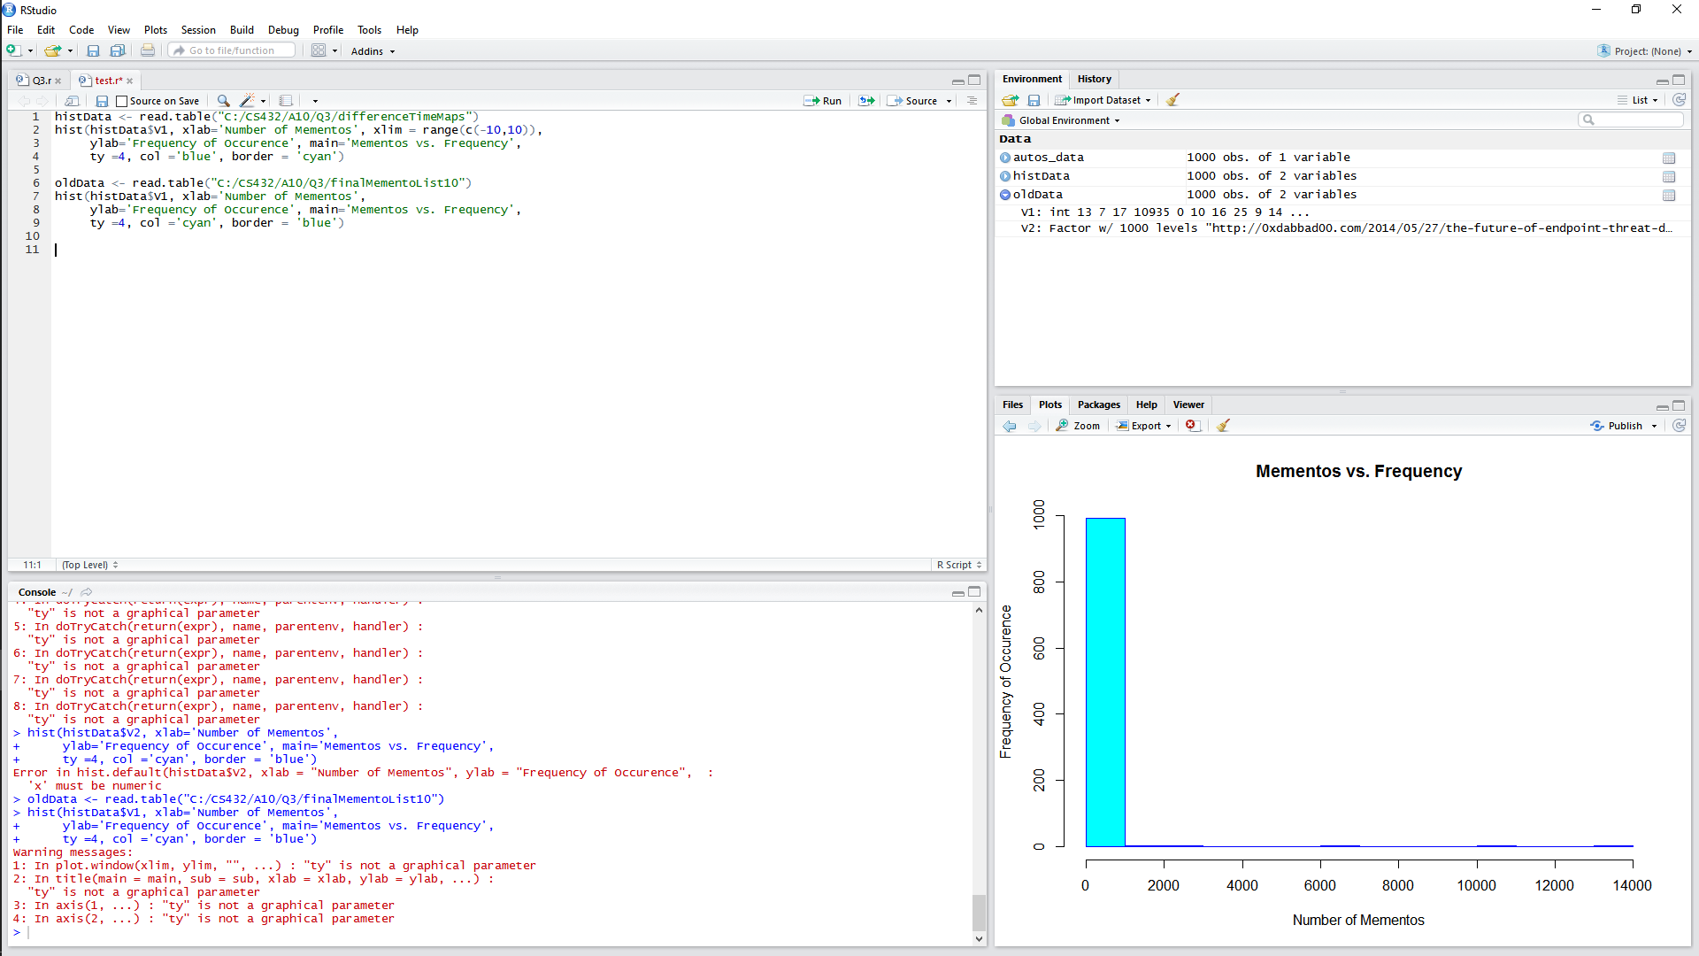

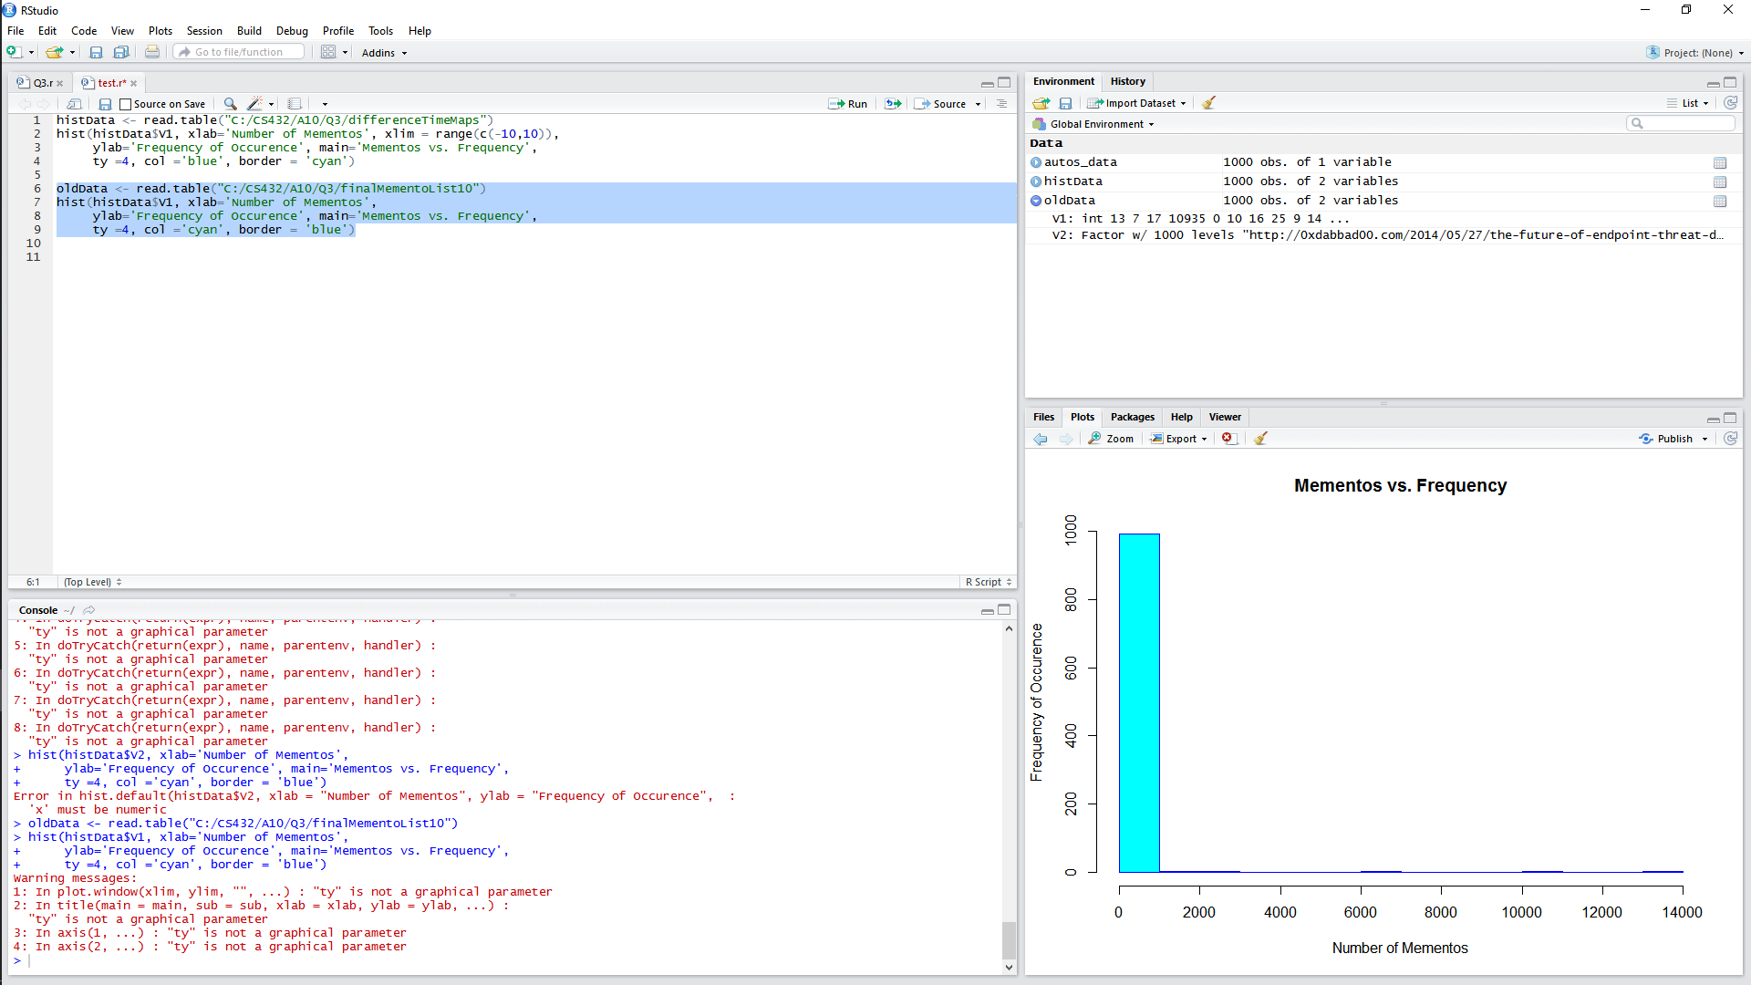



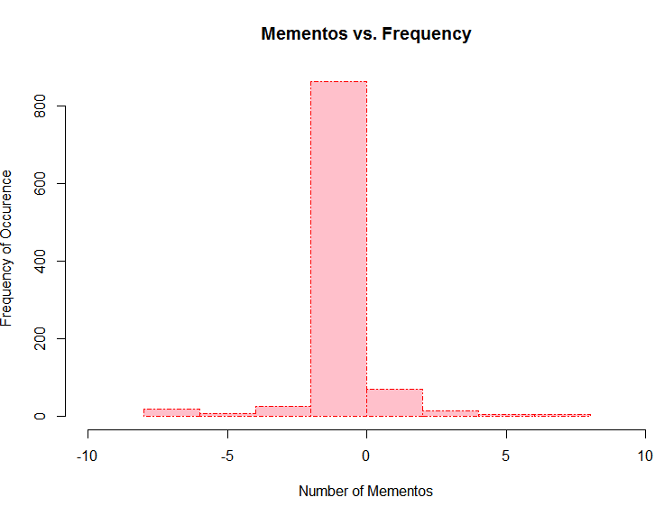

Q4:

Resources:

https://github.com/rreelachart/cs532-s17/tree/master/submissions/assignment%202